1.1.
Product identifier
SECTION 1: Identification of the substance/mixture and of the company/undertaking
Product form : Mixture
Product name : LIQUID RUBBER SEALANT COATING
Vaporizer : Aerosol
1.2. Relevant identified uses of the substance or mixture and uses advised against
Use of the substance/mixture : Consumer uses: Private households (= general public = consumers) Recommended use : Coatings and paints
1.3. Details of the supplier of the safety data sheet
BÖRFH KİMYA SAN VE TİC A.Ş
Hicriye Mahallesi Yukarı Sk No:36/A SAKARYA - TÜRKİYE
T + 90 532 053 20 27
info@borfh.com - www.borfh.com- www.atlantikaerosol.com
1.4. Emergency telephone number

Country | Organisation/Company | Address | Emergency number | Comment
Turkey | Ulusal Zehir Merkezi (UZEM)  Refik Saydam Hıfzıssıhha Merkezi Başkanlığı | Cemal Gürsel Cd. No: 18 Sıhhiye Çankaya  06590 Ankara | 114 | Information is provided to public and medical personnel on poisoning incidents via 114.
2.1.
Classification of the substance or mixture
SECTION 2: Hazards identification

Classification according to Classification, Labelling and Packaging of Substances and Mixtures (SEA) Regulation published in the Official Journal numbered 28848 on December 11, 2013.
Aerosol, Category 1 H222;H229
Serious eye damage/eye irritation, Category 2 H319 Specific target organ toxicity — Single exposure, Category 3, Narcosis H336
Full text of H-statements: see section 16

Adverse physicochemical, human health and environmental effects
: Pressurised container: May burst if heated. Extremely flammable aerosol. May cause drowsiness or dizziness. Causes serious eye irritation.

2.2. Label elements
Classification according to Classification, Labelling and Packaging of Substances and Mixtures (SEA) Regulation published in the Official Journal numbered 28848 on December 11, 2013.
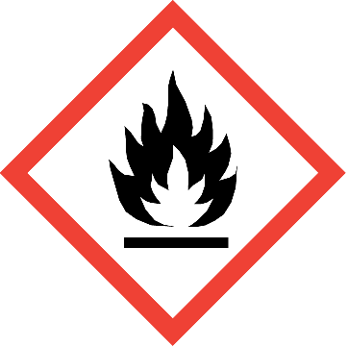
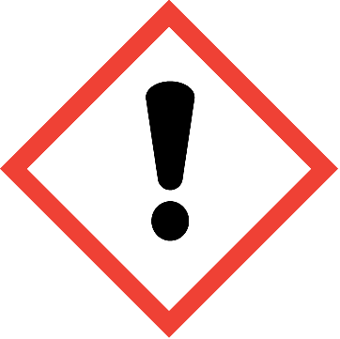
Hazard pictograms (SEA) :

GHS02 GHS07
Signal word (SEA) : Danger
Hazardous ingredients : acetone; propan-2-one; propanone; n-butyl acetate
Hazard statements (SEA) : H222 - Extremely flammable aerosol. H319 - Causes serious eye irritation.
H336 - May cause drowsiness or dizziness.
Precautionary statements (SEA) : P210 - Keep away from heat, hot surfaces, sparks, open flames and other ignition sources. No
smoking.
P251 - Do not pierce or burn, even after use.
P261 - Avoid breathing dust/fume/gas/mist/vapours/spray.
P264 - Wash hands, forearms and face with soap and water thoroughly after handling P271 - Use only outdoors or in a well-ventilated area.
P280 - Wear protective gloves/protective clothing/eye protection/face protection. P304+P340 - IF INHALED: Remove person to fresh air and keep comfortable for breathing.
2.3. Other hazards
Other hazards not contributing to the classification
No additional information available

3.1.
Substances
SECTION 3: Composition/information on ingredients
Not applicable
3.2. Mixtures

Name | Product identifier | % | Classification according to Classification, Labelling and Packaging of Substances and Mixtures (SEA) Regulation published in the Official Journal numbered 28848 on December 11,  2013.
acetone; propan-2-one; propanone | (CAS-No.) 67-64-1  (EC-No.) 200-662-2  (EC Index-No.) 606-001-00-8 | 25 - 50 | Flam. Liq. 2, H225 Eye Irrit. 2, H319 STOT SE 3, H336
n-butyl acetate | (CAS-No.) 123-86-4  (EC-No.) 204-658-1  (EC Index-No.) 607-025-00-1 | 20 - 25 | Flam. Liq. 3, H226 STOT SE 3, H336
propane | (CAS-No.) 74-98-6  (EC-No.) 200-827-9  (EC Index-No.) 601-003-00-5 | 10 - 12.5 | Flam. Gas 1, H220 Press. Gas
butane | (CAS-No.) 106-97-8  (EC-No.) 203-448-7  (EC Index-No.) 601-004-00-0 | 5 - 10 | Flam. Gas 1, H220 Press. Gas
2-methoxy-1-methylethyl acetate | (CAS-No.) 108-65-6  (EC-No.) 203-603-9  (EC Index-No.) 607-195-00-7 | 5 - 10 | Flam. Liq. 3, H226
isobutane | (CAS-No.) 75-28-5  (EC-No.) 200-857-2  (EC Index-No.) 601-004-00-0 | 2.5 - 5 | Flam. Gas 1, H220 Press. Gas

Full text of H-statements: see section 16
4.1.
Description of first aid measures
SECTION 4: First aid measures
First-aid measures general : Call a poison center or a doctor if you feel unwell. Get medical advice/attention if you feel
unwell.
First-aid measures after inhalation : Remove person to fresh air and keep comfortable for breathing. First-aid measures after skin contact : Wash skin with plenty of water.
First-aid measures after eye contact : Rinse eyes with water as a precaution. Rinse cautiously with water for several minutes.
Remove contact lenses, if present and easy to do. Continue rinsing. If eye irritation persists: Get medical advice/attention.
First-aid measures after ingestion : Call a poison center or a doctor if you feel unwell.
4.2. Most important symptoms and effects, both acute and delayed
Symptoms/effects : May cause drowsiness or dizziness.
Symptoms/effects after eye contact : Eye irritation.
4.3. Indication of any immediate medical attention and special treatment needed
Treat symptomatically.
5.1.
Extinguishing media
SECTION 5: Firefighting measures
Suitable extinguishing media : Water spray. Dry powder. Foam. Carbon dioxide.
5.2. Special hazards arising from the substance or mixture
Fire hazard : Extremely flammable aerosol.
Explosion hazard : Pressurised container: May burst if heated.

Hazardous decomposition products in case of fire
: Toxic fumes may be released.

5.3. Advice for firefighters
Protection during firefighting : Do not attempt to take action without suitable protective equipment. Self-contained breathing apparatus. Complete protective clothing.

6.1.
Personal precautions, protective equipment and emergency procedures
SECTION 6: Accidental release measures

For non-emergency personnel
Emergency procedures : Ventilate spillage area. No open flames, no sparks, and no smoking. Avoid breathing
dust/fume/gas/mist/vapours/spray. Avoid contact with skin and eyes.

For emergency responders
Protective equipment : Do not attempt to take action without suitable protective equipment. For further information refer to section 8: "Exposure controls/personal protection".
6.2. Environmental precautions
Avoid release to the environment.
6.3. Methods and material for containment and cleaning up
Methods for cleaning up : Mechanically recover the product.
Other information : Dispose of materials or solid residues at an authorized site.
6.4. Reference to other sections
For further information refer to section 13.
7.1.
Precautions for safe handling
SECTION 7: Handling and storage
Precautions for safe handling : Keep away from heat, hot surfaces, sparks, open flames and other ignition sources. No
smoking. Do not spray on an open flame or other ignition source. Do not pierce or burn, even after use. Use only outdoors or in a well-ventilated area. Avoid breathing dust/fume/gas/mist/vapours/spray. Avoid contact with skin and eyes. Wear personal protective equipment.
Hygiene measures : Do not eat, drink or smoke when using this product. Always wash hands after handling the product.
7.2. Conditions for safe storage, including any incompatibilities
Storage conditions : Protect from sunlight. Do not expose to temperatures exceeding 50 °C/ 122 °F. Store locked up. Store in a well-ventilated place. Keep container tightly closed. Keep cool.
7.3. Specific end use(s)
No additional information available
8.1.
Control parameters
SECTION 8: Exposure controls/personal protection

acetone; propan-2-one; propanone (67-64-1)
EU | Local name | Acetone
EU | IOELV TWA (mg/m³) | 1210 mg/m³
EU | IOELV TWA (ppm) | 500 ppm
EU | Regulatory reference | COMMISSION DIRECTIVE 2000/39/EC
Turkey | Local name | Aseton
Turkey | OEL TWA (mg/m³) | 1210 mg/m³
Turkey | OEL TWA (ppm) | 500 ppm
Turkey | Regulatory reference | 12 Ağustos 2013 Tarihli ve 28733 Sayılı Resmî Gazete
8.2. Exposure controls
Appropriate engineering controls : Ensure good ventilation of the work station. Hand protection : Protective gloves
Eye protection : Safety glasses

Skin and body protection : Wear suitable protective clothing

Respiratory protection : In case of insufficient ventilation, wear suitable respiratory equipment Environmental exposure controls : Avoid release to the environment.
9.1.
Information on basic physical and chemical properties
SECTION 9: Physical and chemical properties
Physical state : Liquid

Appearance : Aerosol.
Colour : Variable
Odour : Characteristic
Odour threshold : No data available
pH : No data available
Relative evaporation rate (butylacetate=1) : No data available Melting point : Not applicable
Freezing point : No data available
Boiling point : No data available
Flash point : No data available
Auto-ignition temperature : No data available
Decomposition temperature : No data available
Flammability (solid, gas) : Extremely flammable aerosol.
Vapour pressure : No data available
Relative vapour density at 20 °C : No data available
Relative density : No data available
Solubility : No data available
Log Pow : No data available
Viscosity, kinematic : No data available
Viscosity, dynamic : No data available
Explosive properties : Pressurised container: May burst if heated.
Oxidising properties : No data available
Explosive limits : No data available
9.2. Other information
No additional information available

10.1. Reactivity
SECTION 10: Stability and reactivity
Extremely flammable aerosol. Pressurised container: May burst if heated.

Chemical stability
Stable under normal conditions.

Possibility of hazardous reactions
No dangerous reactions known under normal conditions of use.

Conditions to avoid
Avoid contact with hot surfaces. Heat. No flames, no sparks. Eliminate all sources of ignition.

Incompatible materials
No additional information available

Hazardous decomposition products
Under normal conditions of storage and use, hazardous decomposition products should not be produced.

11.1. Information on toxicological effects
SECTION 11: Toxicological information
Acute toxicity : Not classified
Skin corrosion/irritation : Not classified
Serious eye damage/irritation : Causes serious eye irritation.
Respiratory or skin sensitisation : Not classified
Germ cell mutagenicity : Not classified
Carcinogenicity : Not classified
Reproductive toxicity : Not classified
STOT-single exposure : May cause drowsiness or dizziness.
STOT-repeated exposure : Not classified
Aspiration hazard : Not classified

ACRYLIC SPRAY PAINT (FOR ALL RAL NUMBERS)
Vaporizer | Aerosol

12.1. Toxicity
SECTION 12: Ecological information

Ecology - general : The product is not considered harmful to aquatic organisms nor to cause long-term adverse effects in the environment.
Acute aquatic toxicity : Not classified
Chronic aquatic toxicity : Not classified

Persistence and degradability
No additional information available

Bioaccumulative potential

LIQUID RUBBER SEALANT COATING
Bioaccumulative potential | No additional information available
  - Mobility in soil

LIQUID RUBBER SEALANT COATING
Mobility in soil | No additional information available
  - Results of PBT and vPvB assessment
No additional information available

Other adverse effects
Ozone : Not classified
Other adverse effects : No additional information available

13.1. Waste treatment methods
SECTION 13: Disposal considerations
Waste treatment methods : Dispose of contents/container in accordance with licensed collector’s sorting instructions.

SECTION 14: Transport information
In accordance with ADR / RID / IMDG / IATA / ADN
ADR |  | IMDG | IATA | ADN | RID
14.1. | UN number
1950 |  | 1950 | 1950 | 1950 | 1950
14.2. | UN proper shipping name
AEROSOLS |  | AEROSOLS | Aerosols, flammable | AEROSOLS | AEROSOLS
Transport document description
UN 1950 AEROSOLS,  2.1, (D) |  | UN 1950 AEROSOLS, 2.1 | UN 1950 Aerosols,  flammable, 2.1 | UN 1950 AEROSOLS, 2.1 | UN 1950 AEROSOLS, 2.1
14.3. | Transport hazard class(es)
2.1 |  | 2.1 | 2.1 | 2.1 | 2.1
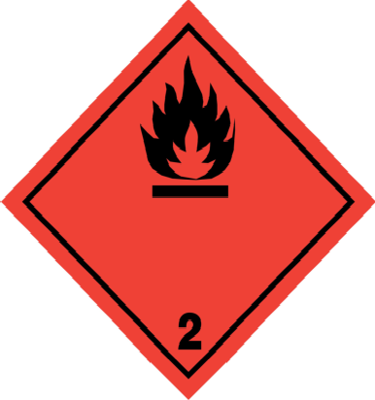 |  | 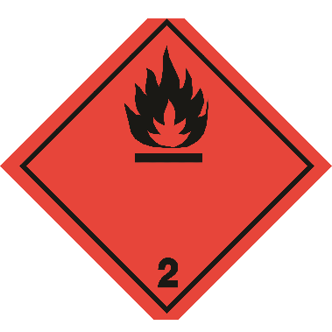 | 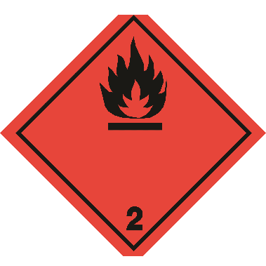
14.4. | Packing group
Not applicable |  | Not applicable | Not applicable | Not applicable | Not applicable
14.5. | Environmental hazards
Dangerous for the environment : No |  | Dangerous for the environment : No Marine pollutant : No | Dangerous for the environment : No | Dangerous for the environment : No | Dangerous for the environment : No
No supplementary information available

Special precautions for user

- Overland transport
Classification code (ADR) : 5F
Special provisions (ADR) : 190, 327, 344, 625

Limited quantities (ADR) : 1l
Excepted quantities (ADR) : E0
Packing instructions (ADR) : P207, LP02
Special packing provisions (ADR) : PP87, RR6, L2
Mixed packing provisions (ADR) : MP9
Transport category (ADR) : 2

Special provisions for carriage - Packages (ADR)
Special provisions for carriage - Loading, unloading and handling (ADR)
Special provisions for carriage - Operation (ADR)
: V14

: CV9, CV12

: S2

Tunnel restriction code (ADR) : D

- Transport by sea
Special provisions (IMDG) : 63, 190, 277, 327, 344, 959
Limited quantities (IMDG) : SP277
Excepted quantities (IMDG) : E0
Packing instructions (IMDG) : P207, LP02
Special packing provisions (IMDG) : PP87, L2
EmS-No. (Fire) : F-D
EmS-No. (Spillage) : S-U
Stowage category (IMDG) : None
Stowage and handling (IMDG) : SW1, SW22
Segregation (IMDG) : SG69

- Air transport
PCA Excepted quantities (IATA) : E0
PCA Limited quantities (IATA) : Y203 PCA limited quantity max net quantity (IATA) : 30kgG PCA packing instructions (IATA) : 203
PCA max net quantity (IATA) : 75kg
CAO packing instructions (IATA) : 203
CAO max net quantity (IATA) : 150kg
Special provisions (IATA) : A145, A167, A802
ERG code (IATA) : 10L

- Inland waterway transport
Classification code (ADN) : 5F
Special provisions (ADN) : 190, 327, 344, 625
Limited quantities (ADN) : 1 L
Excepted quantities (ADN) : E0
Equipment required (ADN) : PP, EX, A
Ventilation (ADN) : VE01, VE04
Number of blue cones/lights (ADN) : 1

- Rail transport
Classification code (RID) : 5F
Special provisions (RID) : 190, 327, 344, 625
Limited quantities (RID) : 1L
Excepted quantities (RID) : E0
Packing instructions (RID) : P207, LP02
Special packing provisions (RID) : PP87, RR6, L2
Mixed packing provisions (RID) : MP9
Transport category (RID) : 2

Special provisions for carriage – Packages (RID)
Special provisions for carriage - Loading, unloading and handling (RID)
: W14

: CW9, CW12

Colis express (express parcels) (RID) : CE2
Hazard identification number (RID) : 23

Transport in bulk according to Annex II of MARPOL 73/78 and the IBC Code
Not applicable

15.1. Safety, health and environmental regulations/legislation specific for the substance or mixture
SECTION 15: Regulatory information

15.1.1. National regulations
This product doesn’t contain any substances that is controlled or prohibited for use according to the Regulation for Reduction of Ozone Depleting Substances published in the Official Journal numbered 27052 on November 12, 2008.
Regulatory reference : Waste Management Regulation published in the Official Journal numbered 29314 on April 2, 2015
Regulation on Test Methods that will be Applied to Determine the Physicochemical, Toxicological and Ecotoxicological Properties of Substances and Mixtures published in the Official Journal numbered 28848 on December 11, 2013
Regulation on Health and Safety Precautions When Working with Chemical Substances published in the Official Journal numbered 28733 on August 12, 2013
Regulation on Inventory and Control of Chemicals published in the Official Journal numbered 27092 on December 26, 2008
Regulation on Restriction and Prohibition of Hazardous Substances and Mixtures published in the Official Journal numbered 27092 on December 26, 2008
Communiqué on Detergents and Surfactants Used in Detergents published in the Official Journal numbered 27092 on December 26, 2008.

SECTION 16: Other information

Full text of H-statements

Eye Irrit. 2 | Serious eye damage/eye irritation, Category 2
Flam. Gas 1 | Flammable gases, Category 1
Flam. Liq. 2 | Flammable liquids, Category 2
Flam. Liq. 3 | Flammable liquids, Category 3
Press. Gas | Gases under pressure
STOT SE 3 | Specific target organ toxicity — Single exposure, Category 3, Narcosis

Safety Data Sheet author's
Name : İrem BEKTAŞ KART
Certificate number : GBF-A-0-2732
Contact information : irem@bekkdanismanlik.com

SDS Turkey

This information is based on our current knowledge and is intended to describe the product for the purposes of health, safety and environmental requirements only. It should not therefore be construed as guaranteeing any specific property of the product

