1.1.
Product identifier
SECTION 1: Identification of the substance/mixture and of the company/undertaking
Product form : Mixture
Product name : PETROL INJECTOR SYSTEM CLEANING
1.2. Relevant identified uses of the substance or mixture and uses advised against
Use of the substance/mixture : It prevents the damages of the institutions and emissions in the engine by cleaning the system.

1.3. Details of the supplier of the safety data sheet
BÖRFH KİMYA SAN VE TİC A.Ş
Hicriye Mahallesi Yukarı Sk No:36/A SAKARYA - TÜRKİYE
T + 90 532 053 20 27
info@borfh.com - www.borfh.com
1.4. Emergency telephone number

Country | Organisation/Company | Address | Emergency number | Comment
Turkey | Ulusal Zehir Merkezi (UZEM)  Refik Saydam Hıfzıssıhha Merkezi Başkanlığı | Cemal Gürsel Cd. No: 18 Sıhhiye Çankaya  06590 Ankara | 114 | Information is provided to public and medical personnel on poisoning incidents via 114.
2.1.
Classification of the substance or mixture
SECTION 2: Hazards identification

Classification according to Classification, Labelling and Packaging of Substances and Mixtures (SEA) Regulation published in the Official Journal numbered 28848 on December 11, 2013.
Flammable liquids, Category 3 H226
Specific target organ toxicity — Single exposure, Category 3, Narcosis H336 Specific target organ toxicity — Repeated exposure, Category 1 H372 Hazardous to the aquatic environment — Chronic Hazard, Category 2 H411
Full text of H-statements: see section 16

Adverse physicochemical, human health and environmental effects
: Flammable liquid and vapour. Causes damage to organs through prolonged or repeated exposure. May cause drowsiness or dizziness. Toxic to aquatic life with long lasting effects.

2.2. Label elements
Classification according to Classification, Labelling and Packaging of Substances and Mixtures (SEA) Regulation published in the Official Journal numbered 28848 on December 11, 2013.
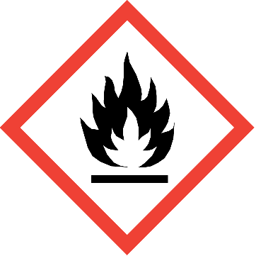

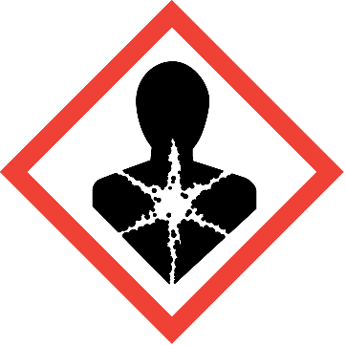
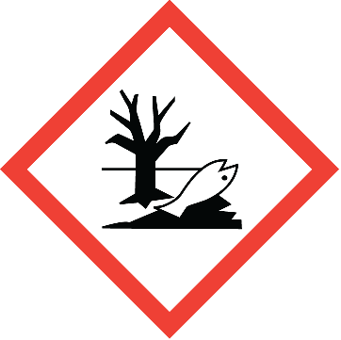
Hazard pictograms (SEA) :

GHS02 GHS07 GHS08 GHS09
Signal word (SEA) : Danger
Hazardous ingredients : Hydrocarbons, C9-C12, n-alkanes, isoalkanes, cyclics, aromatics (2-25%)
Hazard statements (SEA) : H226 - Flammable liquid and vapour.
H336 - May cause drowsiness or dizziness.
H372 - Causes damage to organs through prolonged or repeated exposure. H411 - Toxic to aquatic life with long lasting effects.
Precautionary statements (SEA) : P210 - Keep away from heat, hot surfaces, sparks, open flames and other ignition sources. No
smoking.
P233 - Keep container tightly closed.
P241 - Use explosion-proof electrical/ventilating/lighting equipment. P260 - Do not breathe dust/fume/gas/mist/vapours/spray.
P264 - Wash hands, forearms and face with soap and water thoroughly after handling P270 - Do not eat, drink or smoke when using this product.
2.3. Other hazards
Other hazards not contributing to the classification
No additional information available

3.1.
Substances
SECTION 3: Composition/information on ingredients
Not applicable
3.2. Mixtures

Name | Product identifier | % | Classification according to Classification, Labelling and Packaging of Substances and Mixtures (SEA) Regulation published in the Official Journal numbered 28848 on December 11,  2013.
Hydrocarbons, C9-C12, n-alkanes, isoalkanes, cyclics, aromatics (2-25%) | (CAS-No.) 64742-82-1  (EC-No.) 919-446-0 | 37.5 | Flam. Liq. 3, H226 STOT SE 3, H336 STOT RE 1, H372 Asp. Tox. 1, H304  Aquatic Chronic 2, H411
Hydrocarbons, C10-C13, n-alkanes, isoalkanes, cyclics, < 2% aromatics | (CAS-No.) 64742-48-9  (EC-No.) 918-481-9 | 37.5 | Asp. Tox. 1, H304
Benzene, mono-C10-13-alkyl derivs., distn. residues | (CAS-No.) 84961-70-6  (EC-No.) 284-660-7 | 15 | Asp. Tox. 1, H304
Solvent naphtha (petroleum), heavy arom.; Kerosine— unspecified; [A complex combination of hydrocarbons obtained from distillation of aromatic streams. It consists predominantly of aromatic hydrocarbons having carbon numbers predominantly in the range of C9 through C16 and boiling in the range of approximately 165 °C to 290 °C (330 °F to 554  °F).] | (CAS-No.) 64742-94-5  (EC-No.) 265-198-5  (EC Index-No.) 649-424-00-3 | 1.505 - 3.025 | Asp. Tox. 1, H304
Paraffins (petroleum) normal C5-20 | (CAS-No.) 64771-72-8  (EC-No.) 265-233-4 | 0.25 - 1 | Asp. Tox. 1, H304
Naphtha (petroleum), hydrotreated heavy; Low boiling point ydrogen treated naphtha; [A complex combination of hydrocarbons obtained by treating a petroleum fraction with hydrogen in the presence of a catalyst. It consists of hydrocarbons having carbon numbers predominantly in the range of C6 through C13 and boiling in the range of approximately 65°C to 230°C (149°F to 446°F).] | (CAS-No.) 64742-48-9  (EC-No.) 265-150-3  (EC Index-No.) 649-327-00-6 | 0 - 0.75 | Carc. 1B, H350 Muta. 1B, H340 Asp. Tox. 1, H304
Kerosine (petroleum), hydrodesulfurized; Kerosine— unspecified; [A complex combination of hydrocarbons obtained from a petroleum stock by treating with hydrogen to convert organic sulfur to hydrogen sulfide which is removed. It consists of hydrocarbons having carbon numbers predominantly in the range of C9 through C16 and boiling in the range of approximately 150 °C to 290 °C (302 °F to 554 °F).] | (CAS-No.) 64742-81-0  (EC-No.) 265-184-9  (EC Index-No.) 649-423-00-8 | 0 - 0.75 | Asp. Tox. 1, H304
naphtha (petroleum), hydrodesulphurized heavy; Low boiling point hydrogen treated naphtha; [A complex combination of hydrocarbons obtained from a catalytic hydrodesulfurization process. It consists of hydrocarbons having carbon numbers predominantly in the range of C7 through C12 and boiling in the range of approximately 90°C to 230°C (194°F to 446 °F).] | (CAS-No.) 64742-82-1  (EC-No.) 265-185-4  (EC Index-No.) 649-330-00-2 | 0 - 0.75 | Carc. 1B, H350 Muta. 1B, H340 Asp. Tox. 1, H304 STOT RE 1, H372
Solvent naphtha (petroleum), light arom.; Low boiling point naphtha -unspecified; [A complex combination of hydrocarbons obtained from distillation of aromatic streams. It consists predominantly of aromatic hydrocarbons having carbon numbers predominantly in the range of C8 through C10 and boiling in the range of approximately 135°C to 210°C (275°F to 410°F).] | (CAS-No.) 64742-95-6  (EC-No.) 265-199-0  (EC Index-No.) 649-356-00-4 | 0.25 - 0.495 | Carc. 1B, H350 Muta. 1B, H340 Asp. Tox. 1, H304
1,2,4-trimethylbenzene | (CAS-No.) 95-63-6  (EC-No.) 202-436-9  (EC Index-No.) 601-043-00-3 | 0.25 - 0.495 | Flam. Liq. 3, H226  Acute Tox. 4 (Inhalation), H332 Eye Irrit. 2, H319  STOT SE 3, H335  Skin Irrit. 2, H315 Aquatic Chronic 2, H411
naphthalene | (CAS-No.) 91-20-3  (EC-No.) 202-049-5  (EC Index-No.) 601-052-00-2 | 0.05 - 0.245 | Carc. 2, H351  Acute Tox. 4 (Oral), H302 Aquatic Acute 1, H400 Aquatic Chronic 1, H410
Full text of H-statements: see section 16

4.1.
Description of first aid measures
SECTION 4: First aid measures
First-aid measures general : Get medical advice/attention if you feel unwell. Call a poison center or a doctor if you feel
unwell.
First-aid measures after inhalation : Remove person to fresh air and keep comfortable for breathing.
First-aid measures after skin contact : Rinse skin with water/shower. Wash skin with plenty of water. Take off contaminated clothing.
Take off immediately all contaminated clothing.
First-aid measures after eye contact : Rinse eyes with water as a precaution.
First-aid measures after ingestion : Call a poison center or a doctor if you feel unwell.
4.2. Most important symptoms and effects, both acute and delayed
Symptoms/effects : May cause drowsiness or dizziness.
4.3. Indication of any immediate medical attention and special treatment needed
Treat symptomatically.
5.1.
Extinguishing media
SECTION 5: Firefighting measures
Suitable extinguishing media : Water spray. Dry powder. Foam. Carbon dioxide.
5.2. Special hazards arising from the substance or mixture
Fire hazard : Flammable liquid and vapour.

Hazardous decomposition products in case of fire
: Toxic fumes may be released.

5.3. Advice for firefighters
Protection during firefighting : Do not attempt to take action without suitable protective equipment. Self-contained breathing apparatus. Complete protective clothing.
6.1.
Personal precautions, protective equipment and emergency procedures
SECTION 6: Accidental release measures

For non-emergency personnel
Emergency procedures : Ventilate spillage area. No open flames, no sparks, and no smoking. Do not breathe
dust/fume/gas/mist/vapours/spray.

For emergency responders
Protective equipment : Do not attempt to take action without suitable protective equipment. For further information refer to section 8: "Exposure controls/personal protection".
6.2. Environmental precautions
Avoid release to the environment.
6.3. Methods and material for containment and cleaning up
For containment : Collect spillage.
Methods for cleaning up : Take up liquid spill into absorbent material. Notify authorities if product enters sewers or public
waters.
Other information : Dispose of materials or solid residues at an authorized site.
6.4. Reference to other sections
For further information refer to section 13.
7.1.
Precautions for safe handling
SECTION 7: Handling and storage
Precautions for safe handling : Keep away from heat, hot surfaces, sparks, open flames and other ignition sources. No
smoking. Use only non-sparking tools. Take precautionary measures against static discharge. Flammable vapours may accumulate in the container. Use explosion-proof equipment. Wear personal protective equipment. Do not breathe dust/fume/gas/mist/vapours/spray. Use only outdoors or in a well-ventilated area.
Hygiene measures : Do not eat, drink or smoke when using this product. Always wash hands after handling the product.
7.2. Conditions for safe storage, including any incompatibilities
Storage conditions : Store in a well-ventilated place. Keep cool. Keep container tightly closed. Store locked up.
7.3. Specific end use(s)
No additional information available

8.1.
Control parameters
SECTION 8: Exposure controls/personal protection
No additional information available
8.2. Exposure controls
Appropriate engineering controls : Ensure good ventilation of the work station. Hand protection : Protective gloves
Eye protection : Safety glasses

Respiratory protection : In case of insufficient ventilation, wear suitable respiratory equipment Environmental exposure controls : Avoid release to the environment.
9.1.
Information on basic physical and chemical properties
SECTION 9: Physical and chemical properties
Physical state : Liquid
Colour : Yellow
Odour : No data available
Odour threshold : No data available
pH : No data available
Relative evaporation rate (butylacetate=1) : No data available Melting point : No data available
Freezing point : No data available
Boiling point : 64.7 °C (148.5 °F)
Flash point : 16.6 °C (61.9 °F)
Auto-ignition temperature : No data available
Decomposition temperature : No data available
Flammability (solid, gas) : Not applicable
Vapour pressure : No data available
Relative vapour density at 20 °C : No data available
Relative density : No data available
Solubility : No data available
Log Pow : No data available
Viscosity, kinematic : No data available
Viscosity, dynamic : No data available
Explosive properties : No data available
Oxidising properties : No data available
Explosive limits : No data available
9.2. Other information
No additional information available

10.1. Reactivity
SECTION 10: Stability and reactivity
Flammable liquid and vapour.

10.2. Chemical stability
Stable under normal conditions.

10.3. Possibility of hazardous reactions
No dangerous reactions known under normal conditions of use.

10.4. Conditions to avoid
Avoid contact with hot surfaces. Heat. No flames, no sparks. Eliminate all sources of ignition.

10.5. Incompatible materials
No additional information available

10.6. Hazardous decomposition products
Under normal conditions of storage and use, hazardous decomposition products should not be produced.

11.1. Information on toxicological effects
SECTION 11: Toxicological information
Acute toxicity : Not classified
Skin corrosion/irritation : Not classified
Serious eye damage/irritation : Not classified
Respiratory or skin sensitisation : Not classified
Germ cell mutagenicity : Not classified.
Carcinogenicity : Not classified.
Reproductive toxicity : Not classified
STOT-single exposure : May cause drowsiness or dizziness.
STOT-repeated exposure : Causes damage to organs through prolonged or repeated exposure.
Aspiration hazard : Not classified
12.1. Toxicity
SECTION 12: Ecological information
Ecology - general : Toxic to aquatic life with long lasting effects. Before neutralisation, the product may represent a danger to aquatic organisms.
Acute aquatic toxicity : Not classified
Chronic aquatic toxicity : Toxic to aquatic life with long lasting effects.

Classification procedure (Chronic aquatic toxicity)
: Calculation method

12.2. Persistence and degradability
No additional information available

12.3. Bioaccumulative potential

PETROL INJECTOR SYSTEM CLEANING
Bioaccumulative potential | No additional information available
12.4. Mobility in soil

PETROL INJECTOR SYSTEM CLEANING
Mobility in soil | No additional information available
12.5. Results of PBT and vPvB assessment
No additional information available

12.6. Other adverse effects
Ozone : Not classified
Other adverse effects : No additional information available

13.1. Waste treatment methods
SECTION 13: Disposal considerations
Waste treatment methods : Dispose of contents/container in accordance with licensed collector’s sorting instructions. Additional information : Flammable vapours may accumulate in the container.

SECTION 14: Transport information
In accordance with ADR / RID / IMDG / IATA / ADN
ADR | IMDG | IATA | ADN | RID
14.1. UN number
1993 | 1993 | 1993 | 1993 | 1993
14.2. UN proper shipping name
FLAMMABLE LIQUID, N.O.S. | FLAMMABLE LIQUID, N.O.S. | Flammable liquid, n.o.s. | FLAMMABLE LIQUID, N.O.S. | FLAMMABLE LIQUID, N.O.S.
Transport document description
UN 1993 FLAMMABLE LIQUID, N.O.S., 3, III, (D/E), ENVIRONMENTALLY HAZARDOUS | UN 1993 FLAMMABLE LIQUID, N.O.S., 3, III, MARINE POLLUTANT/ENVIRONM ENTALLY HAZARDOUS | UN 1993 Flammable liquid, n.o.s., 3, III, ENVIRONMENTALLY HAZARDOUS | UN 1993 FLAMMABLE LIQUID, N.O.S., 3, III, ENVIRONMENTALLY HAZARDOUS | UN 1993 FLAMMABLE LIQUID, N.O.S., 3, III, ENVIRONMENTALLY HAZARDOUS

ADR | IMDG |  | IATA ADN RID
14.3. | Transport hazard class(es)
3 |  | 3 | 3 | 3 | 3
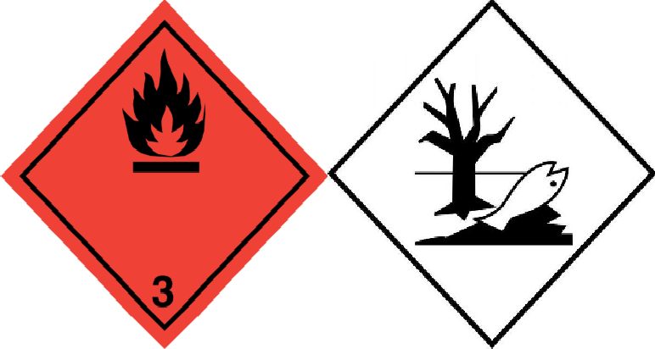 |  | 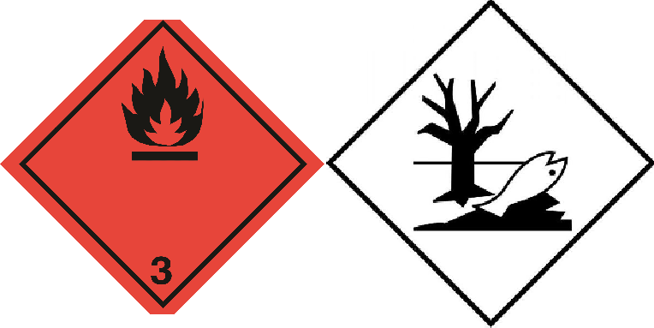
14.4. | Packing group
III |  | III | III | III | III
14.5. | Environmental hazards
Dangerous for the environment : Yes |  | Dangerous for the environment : Yes Marine pollutant : Yes | Dangerous for the environment : Yes | Dangerous for the environment : Yes | Dangerous for the environment : Yes
No supplementary information available

14.6. Special precautions for user

- Overland transport
Classification code (ADR) : F1
Special provisions (ADR) : 274, 601, 640E
Limited quantities (ADR) : 5l
Excepted quantities (ADR) : E1
Packing instructions (ADR) : P001, IBC03, LP01, R001
Mixed packing provisions (ADR) : MP19

Portable tank and bulk container instructions (ADR)
Portable tank and bulk container special provisions (ADR)
: T4

: TP1, TP29

Tank code (ADR) : LGBF
Vehicle for tank carriage : FL
Transport category (ADR) : 3

Special provisions for carriage - Packages (ADR)
Special provisions for carriage - Operation (ADR)
: V12

: S2

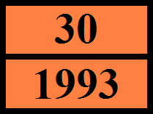
Hazard identification number (Kemler No.) : 30 Orange plates :

Tunnel restriction code (ADR) : D/E

- Transport by sea
Special provisions (IMDG) : 223, 274, 955
Limited quantities (IMDG) : 5 L
Excepted quantities (IMDG) : E1
Packing instructions (IMDG) : P001, LP01
IBC packing instructions (IMDG) : IBC03
Tank instructions (IMDG) : T4
Tank special provisions (IMDG) : TP1, TP29
EmS-No. (Fire) : F-E
EmS-No. (Spillage) : S-E
Stowage category (IMDG) : A

- Air transport
PCA Excepted quantities (IATA) : E1
PCA Limited quantities (IATA) : Y344 PCA limited quantity max net quantity (IATA) : 10L PCA packing instructions (IATA) : 355
PCA max net quantity (IATA) : 60L

CAO packing instructions (IATA) : 366
CAO max net quantity (IATA) : 220L
Special provisions (IATA) : A3
ERG code (IATA) : 3L

- Inland waterway transport
Classification code (ADN) : F1
Special provisions (ADN) : 274, 601, 640E
Limited quantities (ADN) : 5 L
Excepted quantities (ADN) : E1
Carriage permitted (ADN) : T
Equipment required (ADN) : PP, EX, A
Ventilation (ADN) : VE01
Number of blue cones/lights (ADN) : 0

- Rail transport
Classification code (RID) : F1
Special provisions (RID) : 274, 601, 640E
Limited quantities (RID) : 5L
Excepted quantities (RID) : E1
Packing instructions (RID) : P001, IBC03, LP01, R001
Mixed packing provisions (RID) : MP19

Portable tank and bulk container instructions (RID)
Portable tank and bulk container special provisions (RID)
: T4

: TP1, TP29

Tank codes for RID tanks (RID) : LGBF
Transport category (RID) : 3

Special provisions for carriage – Packages (RID)
: W12

Colis express (express parcels) (RID) : CE4
Hazard identification number (RID) : 30

14.7. Transport in bulk according to Annex II of MARPOL 73/78 and the IBC Code
Not applicable

15.1. Safety, health and environmental regulations/legislation specific for the substance or mixture
SECTION 15: Regulatory information

15.1.1. National regulations
This product doesn’t contain any substances that is controlled or prohibited for use according to the Regulation for Reduction of Ozone Depleting Substances published in the Official Journal numbered 27052 on November 12, 2008.
Regulatory reference : Waste Management Regulation published in the Official Journal numbered 29314 on April 2, 2015
Regulation on Test Methods that will be Applied to Determine the Physicochemical, Toxicological and Ecotoxicological Properties of Substances and Mixtures published in the Official Journal numbered 28848 on December 11, 2013
Regulation on Health and Safety Precautions When Working with Chemical Substances published in the Official Journal numbered 28733 on August 12, 2013
Regulation on Inventory and Control of Chemicals published in the Official Journal numbered 27092 on December 26, 2008
Regulation on Restriction and Prohibition of Hazardous Substances and Mixtures published in the Official Journal numbered 27092 on December 26, 2008
Communiqué on Detergents and Surfactants Used in Detergents published in the Official Journal numbered 27092 on December 26, 2008.

SECTION 16: Other information

Full text of H-statements

Acute Tox. 4 (Inhalation) | Acute toxicity (inhal.), Category 4
Acute Tox. 4 (Oral) | Acute toxicity (oral), Category 4

Aquatic Acute 1 | Hazardous to the aquatic environment — Acute Hazard, Category 1
Aquatic Chronic 1 | Hazardous to the aquatic environment — Chronic Hazard, Category 1
Aquatic Chronic 2 | Hazardous to the aquatic environment — Chronic Hazard, Category 2
Asp. Tox. 1 | Aspiration hazard, Category 1
Carc. 1B | Carcinogenicity, Category 1B
Carc. 2 | Carcinogenicity, Category 2
Eye Irrit. 2 | Serious eye damage/eye irritation, Category 2
Flam. Liq. 3 | Flammable liquids, Category 3
Muta. 1B | Germ cell mutagenicity, Category 1B
Skin Irrit. 2 | Skin corrosion/irritation, Category 2
STOT RE 1 | Specific target organ toxicity — Repeated exposure, Category 1
STOT SE 3 | Specific target organ toxicity — Single exposure, Category 3, Respiratory tract irritation
STOT SE 3 | Specific target organ toxicity — Single exposure, Category 3, Narcosis

Safety Data Sheet author's
Name : İrem BEKTAŞ KART
Certificate number : GBF-A-0-2732
Contact information : irem@bekkdanismanlik.com

SDS Turkey

This information is based on our current knowledge and is intended to describe the product for the purposes of health, safety and environmental requirements only. It should not therefore be construed as guaranteeing any specific property of the product

