1.1.
Product identifier
SECTION 1: Identification of the substance/mixture and of the company/undertaking
Product form : Mixture
Product name : PLASTIC PARTS RESTORATION
Vaporizer : Aerosol
1.2. Relevant identified uses of the substance or mixture and uses advised against
Use of the substance/mixture : PLASTIC PARTS RESTORATION

1.3. Details of the supplier of the safety data sheet
BÖRFH KİMYA SAN VE TİC A.Ş
Hicriye Mahallesi Yukarı Sk No:36/A SAKARYA - TÜRKİYE
T + 90 532 053 20 27
info@borfh.com - www.borfh.com
1.4. Emergency telephone number

Country | Organisation/Company | Address | Emergency number | Comment
Turkey | Ulusal Zehir Merkezi (UZEM)  Refik Saydam Hıfzıssıhha Merkezi Başkanlığı | Cemal Gürsel Cd. No: 18 Sıhhiye Çankaya  06590 Ankara | 114 | Information is provided to public and medical personnel on poisoning incidents via 114.
2.1.
Classification of the substance or mixture
SECTION 2: Hazards identification

Classification according to Classification, Labelling and Packaging of Substances and Mixtures (SEA) Regulation published in the Official Journal numbered 28848 on December 11, 2013.
Aerosol, Category 1 H222;H229
Skin corrosion/irritation, Category 2 H315
Skin sensitisation, Category 1 H317
Reproductive toxicity, Category 2 H361
Specific target organ toxicity — Single exposure, Category 3, Narcosis H336 Specific target organ toxicity — Repeated exposure, Category 2 H373 Hazardous to the aquatic environment — Chronic Hazard, Category 2 H411
Full text of H-statements: see section 16

Adverse physicochemical, human health and environmental effects
: Pressurised container: May burst if heated. Extremely flammable aerosol. Toxic to aquatic life with long lasting effects. May cause damage to organs through prolonged or repeated exposure. May cause drowsiness or dizziness. Causes skin irritation. Suspected of damaging fertility or the unborn child. May cause an allergic skin reaction.

2.2. Label elements
Classification according to Classification, Labelling and Packaging of Substances and Mixtures (SEA) Regulation published in the Official Journal numbered 28848 on December 11, 2013.
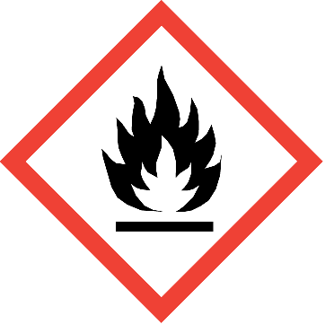
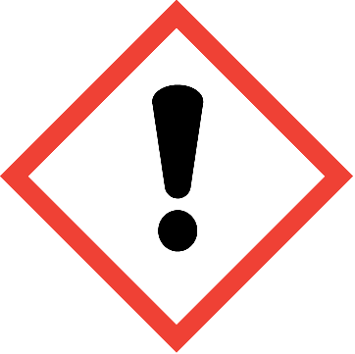
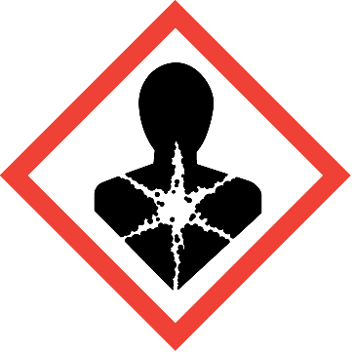
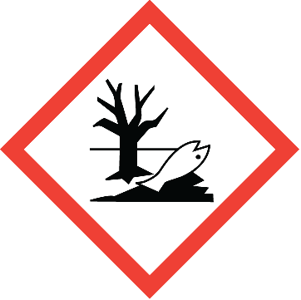
Hazard pictograms (SEA) :

GHS02 GHS07 GHS08 GHS09
Signal word (SEA) : Danger
Hazardous ingredients : n-hexane; (R)-p-mentha-1,8-diene; d-limonene
Hazard statements (SEA) : H222 - Extremely flammable aerosol.
H315 - Causes skin irritation.
H317 - May cause an allergic skin reaction. H336 - May cause drowsiness or dizziness.
H361 - Suspected of damaging fertility or the unborn child.
H373 - May cause damage to organs through prolonged or repeated exposure. H411 - Toxic to aquatic life with long lasting effects.
Precautionary statements (SEA) : P201 - Obtain special instructions before use.
P210 - Keep away from heat, hot surfaces, sparks, open flames and other ignition sources. No smoking.

P251 - Do not pierce or burn, even after use.
P260 - Do not breathe dust/fume/gas/mist/vapours/spray.
P264 - Wash hands, forearms and face with soap and water thoroughly after handling P271 - Use only outdoors or in a well-ventilated area.
2.3. Other hazards
Other hazards not contributing to the classification
No additional information available
3.1.
Substances
SECTION 3: Composition/information on ingredients
Not applicable
3.2. Mixtures

Name | Product identifier | % | Classification according to Classification, Labelling and Packaging of Substances and Mixtures (SEA) Regulation published in the Official Journal numbered 28848 on December 11,  2013.
Liquefied petroleum gases - LPG | (CAS-No.) 68476-85-7  (EC-No.) 270-704-2 | 60 | Flam. Gas 1, H220  Press. Gas (Comp.), H280
n-hexane | (CAS-No.) 110-54-3  (EC-No.) 203-777-6  (EC Index-No.) 601-037-00-0 | 30 | Flam. Liq. 2, H225 Repr. 2, H361f Asp. Tox. 1, H304 STOT RE 2, H373  Skin Irrit. 2, H315 STOT SE 3, H336  Aquatic Chronic 2, H411
(R)-p-mentha-1,8-diene; d-limonene | (CAS-No.) 5989-27-5  (EC-No.) 227-813-5  (EC Index-No.) 601-029-00-7 | 5 | Flam. Liq. 3, H226 Skin Irrit. 2, H315 Skin Sens. 1, H317 Aquatic Acute 1, H400  Aquatic Chronic 1, H410
Phenyl methicone | (CAS-No.) 63148-58-3 | 5 | Not classified
Specific concentration limits:
Name | Product identifier | Specific concentration limits
n-hexane | (CAS-No.) 110-54-3  (EC-No.) 203-777-6  (EC Index-No.) 601-037-00-0 | ( 5 =<C < 100) STOT RE 2, H373
Full text of H-statements: see section 16
4.1.
Description of first aid measures
SECTION 4: First aid measures
First-aid measures general : Get medical advice/attention if you feel unwell.
First-aid measures after inhalation : Remove person to fresh air and keep comfortable for breathing.
First-aid measures after skin contact : Wash skin with plenty of water. Take off contaminated clothing. If skin irritation or rash occurs:
Get medical advice/attention.
First-aid measures after eye contact : If eye irritation persists: Get medical advice/attention. First-aid measures after ingestion : Call a poison center or a doctor if you feel unwell.
4.2. Most important symptoms and effects, both acute and delayed
Symptoms/effects : May cause drowsiness or dizziness. Symptoms/effects after skin contact : Irritation. May cause an allergic skin reaction.
4.3. Indication of any immediate medical attention and special treatment needed
Treat symptomatically.
5.1.
Extinguishing media
SECTION 5: Firefighting measures
Suitable extinguishing media : Water spray. Dry powder. Foam. Carbon dioxide.
5.2. Special hazards arising from the substance or mixture
Fire hazard : Extremely flammable aerosol.

Explosion hazard : Pressurised container: May burst if heated.

Hazardous decomposition products in case of fire
: Toxic fumes may be released.

5.3. Advice for firefighters
Protection during firefighting : Do not attempt to take action without suitable protective equipment. Self-contained breathing apparatus. Complete protective clothing.
6.1.
Personal precautions, protective equipment and emergency procedures
SECTION 6: Accidental release measures

For non-emergency personnel
Emergency procedures : Ventilate spillage area. No open flames, no sparks, and no smoking. Do not breathe
dust/fume/gas/mist/vapours/spray. Avoid contact with skin and eyes.

For emergency responders
Protective equipment : Do not attempt to take action without suitable protective equipment. For further information refer to section 8: "Exposure controls/personal protection".
6.2. Environmental precautions
Avoid release to the environment.
6.3. Methods and material for containment and cleaning up
For containment : Collect spillage.
Methods for cleaning up : Mechanically recover the product. Notify authorities if product enters sewers or public waters. Other information : Dispose of materials or solid residues at an authorized site.
6.4. Reference to other sections
For further information refer to section 13.
7.1.
Precautions for safe handling
SECTION 7: Handling and storage
Precautions for safe handling : Keep away from heat, hot surfaces, sparks, open flames and other ignition sources. No
smoking. Do not spray on an open flame or other ignition source. Do not pierce or burn, even after use. Do not breathe dust/fume/gas/mist/vapours/spray. Use only outdoors or in a well- ventilated area. Avoid contact with skin and eyes. Wear personal protective equipment. Obtain special instructions before use. Do not handle until all safety precautions have been read and understood.
Hygiene measures : Wash contaminated clothing before reuse. Do not eat, drink or smoke when using this product.
Always wash hands after handling the product. Contaminated work clothing should not be allowed out of the workplace.
7.2. Conditions for safe storage, including any incompatibilities
Storage conditions : Protect from sunlight. Do not expose to temperatures exceeding 50 °C/ 122 °F. Store locked up. Store in a well-ventilated place. Keep container tightly closed. Keep cool.
7.3. Specific end use(s)
No additional information available
8.1.
Control parameters
SECTION 8: Exposure controls/personal protection
No additional information available
8.2. Exposure controls
Appropriate engineering controls : Ensure good ventilation of the work station. Hand protection : Protective gloves
Eye protection : Safety glasses

Skin and body protection : Wear suitable protective clothing

Respiratory protection : [In case of inadequate ventilation] wear respiratory protection. Environmental exposure controls : Avoid release to the environment.

9.1.
Information on basic physical and chemical properties
SECTION 9: Physical and chemical properties
Physical state : Liquid
Appearance : Clear
Colour : Colourless
Odour : No data available
Odour threshold : No data available
pH : No data available
Relative evaporation rate (butylacetate=1) : No data available Melting point : Not applicable
Freezing point : No data available
Boiling point : No data available
Flash point : No data available
Auto-ignition temperature : No data available
Decomposition temperature : No data available
Flammability (solid, gas) : Extremely flammable aerosol.
Vapour pressure : No data available
Relative vapour density at 20 °C : No data available
Relative density : No data available
Solubility : No data available
Log Pow : No data available
Viscosity, kinematic : No data available
Viscosity, dynamic : No data available
Explosive properties : Pressurised container: May burst if heated.
Oxidising properties : No data available
Explosive limits : No data available
9.2. Other information
No additional information available

10.1. Reactivity
SECTION 10: Stability and reactivity
Extremely flammable aerosol. Pressurised container: May burst if heated.

Chemical stability
Stable under normal conditions.

Possibility of hazardous reactions
No dangerous reactions known under normal conditions of use.

Conditions to avoid
Avoid contact with hot surfaces. Heat. No flames, no sparks. Eliminate all sources of ignition.

Incompatible materials
No additional information available

Hazardous decomposition products
Under normal conditions of storage and use, hazardous decomposition products should not be produced.

11.1. Information on toxicological effects
SECTION 11: Toxicological information
Acute toxicity : Not classified
Skin corrosion/irritation : Causes skin irritation.
Serious eye damage/irritation : Not classified
Respiratory or skin sensitisation : May cause an allergic skin reaction.
Germ cell mutagenicity : Not classified
Carcinogenicity : Not classified
Reproductive toxicity : Suspected of damaging fertility or the unborn child.
STOT-single exposure : May cause drowsiness or dizziness.
STOT-repeated exposure : May cause damage to organs through prolonged or repeated exposure.

Aspiration hazard : Not classified

PLASTIC PARTS RESTORATION
Vaporizer | Aerosol
12.1. Toxicity
SECTION 12: Ecological information

Ecology - general : Toxic to aquatic life with long lasting effects. Before neutralisation, the product may represent a danger to aquatic organisms.
Acute aquatic toxicity : Not classified
Chronic aquatic toxicity : Toxic to aquatic life with long lasting effects.

Classification procedure (Chronic aquatic toxicity)
: Calculation method

Persistence and degradability
No additional information available

Bioaccumulative potential

PLASTIC PARTS RESTORATION
Bioaccumulative potential | No additional information available
  - Mobility in soil

PLASTIC PARTS RESTORATION
Mobility in soil | No additional information available
  - Results of PBT and vPvB assessment
No additional information available

Other adverse effects
Ozone : Not classified
Other adverse effects : No additional information available

13.1. Waste treatment methods
SECTION 13: Disposal considerations
Waste treatment methods : Dispose of contents/container in accordance with licensed collector’s sorting instructions.

SECTION 14: Transport information
In accordance with ADR / RID / IMDG / IATA / ADN
ADR | IMDG | IATA | ADN | RID
14.1. UN number
1950 | 1950 | 1950 | 1950 | 1950
14.2. UN proper shipping name
AEROSOLS | AEROSOLS | Aerosols, flammable | AEROSOLS | AEROSOLS
Transport document description
UN 1950 AEROSOLS,  2.1, (D), ENVIRONMENTALLY HAZARDOUS | UN 1950 AEROSOLS,  2.1, MARINE POLLUTANT/ENVIRONM ENTALLY HAZARDOUS | UN 1950 Aerosols,  flammable, 2.1, ENVIRONMENTALLY HAZARDOUS | UN 1950 AEROSOLS,  2.1, ENVIRONMENTALLY HAZARDOUS | UN 1950 AEROSOLS,  2.1, ENVIRONMENTALLY HAZARDOUS
14.3. Transport hazard class(es)
2.1 | 2.1 | 2.1 | 2.1 | 2.1
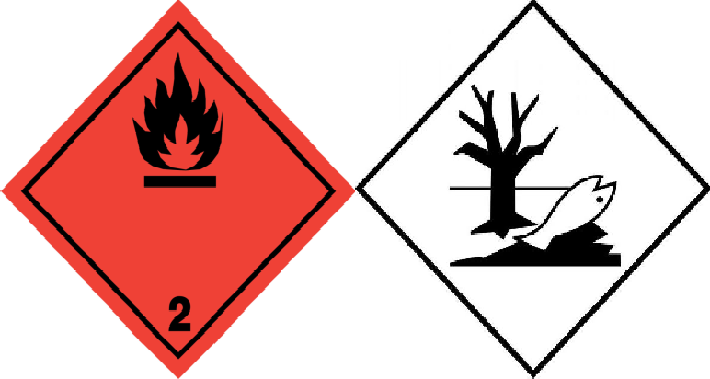 | 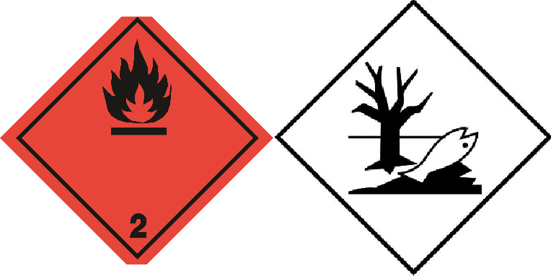 | 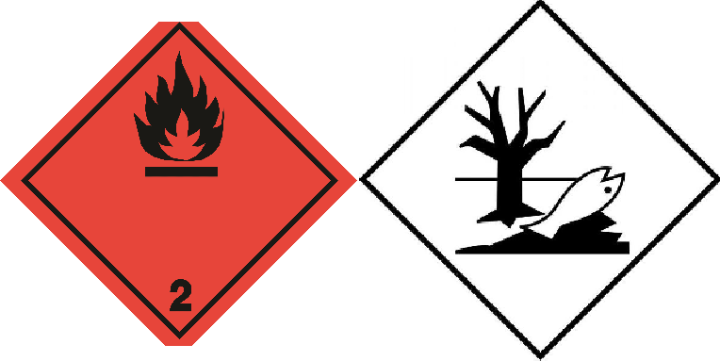 | 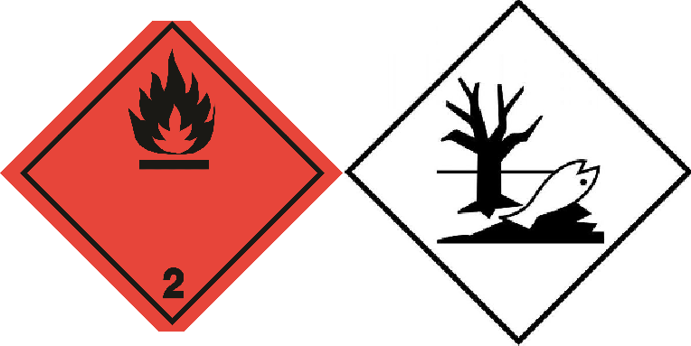
14.4. Packing group
Not applicable | Not applicable | Not applicable | Not applicable | Not applicable
14.5. Environmental hazards
Dangerous for the | Dangerous for the environment : Yes | Dangerous for the | Dangerous for the | Dangerous for the

ADR | IMDG | IATA | ADN | RID
environment : Yes | Marine pollutant : Yes | environment : Yes | environment : Yes | environment : Yes
No supplementary information available

Special precautions for user

- Overland transport
Classification code (ADR) : 5F
Special provisions (ADR) : 190, 327, 344, 625
Limited quantities (ADR) : 1l
Excepted quantities (ADR) : E0
Packing instructions (ADR) : P207, LP200
Special packing provisions (ADR) : PP87, RR6, L2
Mixed packing provisions (ADR) : MP9
Transport category (ADR) : 2

Special provisions for carriage - Packages (ADR)
Special provisions for carriage - Loading, unloading and handling (ADR)
Special provisions for carriage - Operation (ADR)
: V14

: CV9, CV12

: S2

Tunnel restriction code (ADR) : D

- Transport by sea
Special provisions (IMDG) : 63, 190, 277, 327, 344, 381, 959
Packing instructions (IMDG) : P207, LP200
Special packing provisions (IMDG) : PP87, L2
EmS-No. (Fire) : F-D
EmS-No. (Spillage) : S-U
Stowage category (IMDG) : None
Stowage and handling (IMDG) : SW1, SW22
Segregation (IMDG) : SG69

- Air transport
PCA Excepted quantities (IATA) : E0
PCA Limited quantities (IATA) : Y203 PCA limited quantity max net quantity (IATA) : 30kgG PCA packing instructions (IATA) : 203
PCA max net quantity (IATA) : 75kg
CAO packing instructions (IATA) : 203
CAO max net quantity (IATA) : 150kg
Special provisions (IATA) : A145, A167, A802
ERG code (IATA) : 10L

- Inland waterway transport
Classification code (ADN) : 5F
Special provisions (ADN) : 190, 327, 344, 625
Limited quantities (ADN) : 1 L
Excepted quantities (ADN) : E0
Equipment required (ADN) : PP, EX, A
Ventilation (ADN) : VE01, VE04
Number of blue cones/lights (ADN) : 1

- Rail transport
Classification code (RID) : 5F
Special provisions (RID) : 190, 327, 344, 625
Limited quantities (RID) : 1L
Excepted quantities (RID) : E0
Packing instructions (RID) : P207, LP200

Special packing provisions (RID) : PP87, RR6, L2
Mixed packing provisions (RID) : MP9
Transport category (RID) : 2

Special provisions for carriage – Packages (RID)
Special provisions for carriage - Loading, unloading and handling (RID)
: W14

: CW9, CW12

Colis express (express parcels) (RID) : CE2
Hazard identification number (RID) : 23

Transport in bulk according to Annex II of MARPOL 73/78 and the IBC Code
Not applicable

15.1. Safety, health and environmental regulations/legislation specific for the substance or mixture
SECTION 15: Regulatory information

15.1.1. National regulations
This product doesn’t contain any substances that is controlled or prohibited for use according to the Regulation for Reduction of Ozone Depleting Substances published in the Official Journal numbered 27052 on November 12, 2008.
Regulatory reference : Waste Management Regulation published in the Official Journal numbered 29314 on April 2, 2015
Regulation on Test Methods that will be Applied to Determine the Physicochemical, Toxicological and Ecotoxicological Properties of Substances and Mixtures published in the Official Journal numbered 28848 on December 11, 2013
Regulation on Health and Safety Precautions When Working with Chemical Substances published in the Official Journal numbered 28733 on August 12, 2013
Regulation on Inventory and Control of Chemicals published in the Official Journal numbered 27092 on December 26, 2008
Regulation on Restriction and Prohibition of Hazardous Substances and Mixtures published in the Official Journal numbered 27092 on December 26, 2008
Communiqué on Detergents and Surfactants Used in Detergents published in the Official Journal numbered 27092 on December 26, 2008.

SECTION 16: Other information

Full text of H-statements

Aquatic Acute 1 | Hazardous to the aquatic environment — Acute Hazard, Category 1
Aquatic Chronic 1 | Hazardous to the aquatic environment — Chronic Hazard, Category 1
Aquatic Chronic 2 | Hazardous to the aquatic environment — Chronic Hazard, Category 2
Asp. Tox. 1 | Aspiration hazard, Category 1
Flam. Gas 1 | Flammable gases, Category 1
Flam. Liq. 2 | Flammable liquids, Category 2
Flam. Liq. 3 | Flammable liquids, Category 3
Press. Gas (Comp.) | Gases under pressure : Compressed gas
Repr. 2 | Reproductive toxicity, Category 2
Skin Irrit. 2 | Skin corrosion/irritation, Category 2
Skin Sens. 1 | Skin sensitisation, Category 1
STOT RE 2 | Specific target organ toxicity — Repeated exposure, Category 2
STOT SE 3 | Specific target organ toxicity — Single exposure, Category 3, Narcosis

Safety Data Sheet author's
Name : İrem BEKTAŞ KART
Certificate number : GBF-A-0-2732
Contact information : irem@bekkdanismanlik.com

SDS Turkey

This information is based on our current knowledge and is intended to describe the product for the purposes of health, safety and environmental requirements only. It should not therefore be construed as guaranteeing any specific property of the product

